Replication of “Why People Are Reluctant to Tempt Fate” by Risen & Gilovich

(2008, *Journal of Personality and Social Psychology*)

Maya Mathur

mmathur@stanford.edu

**Introduction**

Risen & Gilovich (2008) performed a series of six experiments examining the existence and mechanisms of the belief that “tempting fate” is punished with ironic bad outcomes. For example, the authors postulate, a student may perceive himself as more likely to be called on in class to answer a question if he failed to do the assigned reading than if he had come to class prepared. This form of irrational thinking was hypothesized to originate from System 1 cognitive processes, which use simple cognitive heuristics to render fast, effortless judgments. In contrast, System 2 processes can override System 1’s sometimes inaccurate judgments using rule-based, “rational” thinking.

The authors hypothesized that System 2 processes can act to suppress irrational aversion to tempting fate, and thus that under a cognitive load that preoccupies System 2 resources, the effect tempting fate on perceived likelihood of bad luck would be magnified. Study 6, the target of replication, assessed this possibility by manipulating in a between-subjects factorial design the behavior of a character in a scenario (had done the assigned reading vs. had not) and the presence of cognitive load (load vs. no load) on participants. The key finding, as predicted, was a significant interaction between behavior and load, such that the presence of cognitive load increased the effect of tempting fate vs. not.

**Methods**

Power analysis

Power for a 2 X 2 ANOVA (cognitive load vs. not X had-read vs. not) was estimated by a resampling simulation in R. We will use a total sample size of N=230, divided evenly among 4 conditions, which produces about 80% power to detect the interaction (the primary endpoint) and nearly 100% power to detect each main effect.

Planned sample

Data collection will end either when the target N=230 is reached or by March 16, 2012, whichever comes first. We will conduct our replication online via he crowdsourcing website Amazon Mechanical Turk, so the sampling frame will consist of all registered online workers (“Turkers”) on the website. This sampling frame is in contrast to the Cornell undergraduate subjects used in the original study. However, Burmeister, Kwang, and Gosling (2011) recently characterized Turkers’ demographics and performance on psychology tasks relative to traditional undergraduate samples, finding that the two populations contribute data of comparable reliability and with comparable results in replications of classic psychology studies.

The following pre-selection rules will be employed:

* U.S. resident
* HIT approval rate (percent of Mechanical Turk tasks approved by the original requester) ≥95%

Materials

The original study questionnaire consisting of a scenario, a cognitive load task, and a manipulation check will be replicated exactly in online format via Amazon Mechanical Turk.

Procedure

In accordance with the original study: “Participants read one of the self-scenarios … which asked them to imagine themselves in a large lecture and to imagine that the professor is planning to call on a student because no one has volunteered to answer the question. Participants either read that they have done the reading for class or that they have not done the reading. Half of the participants who read each scenario were under cognitive load. While reading the story and answering the likelihood question, participants under load were required to count backwards by 3s, starting with 564. Participants indicated how likely they believed it was that they would be called on by circling a number between 0 and 10, anchored at 0 with *not at all likely* and at 10 with *extremely likely*. After answering the question, participants under load were told to stop counting and to report the number on which they ended. They also indicated how much effort they put into the two tasks by circling a number between 0 and 6, anchored at 0 with *I put all my effort into reading* and at 6 with *I put all my effort into counting.”*

The original procedure will be replicated exactly, except that the questionnaire will be administered online instead of in paper form.

Analysis plan

No specific data cleaning or exclusion rules are mentioned, although the authors report excluding 2 subjects “because they ended on a number less than 3 away from their starting number (561 and 563), suggesting that they did not count backwards while they read the story. This was confirmed by the manipulation check, in which both participants indicated putting all their effort into reading the story.”

In this spirit, we will exclude any participants who report an ending number > 561 (since this would indicate either having failed to do the counting task or having counted forward instead of backward) and/or indicate having put all their effort into reading the story. Additionally, we will exclude all data from any participants completing the study multiple times.

Risen & Gilovich report the following statistical analyses and descriptive statistics:

1. A “2 (behavior: had read vs. had not read) X 2 (load: yes vs. no) ANOVA,” revealing two main effects and the predicted interaction
2. Two pairwise t-tests and Cohen’s d statistics for effect of behavior (had read vs. had not read), stratifying by load (yes vs. no)

The above analyses will be replicated exactly provided that statistical assumptions hold. In the event of serious non-Normality or heteroscedasticity of variances, standard nonparametric alternatives will be substituted for the ANOVA and t-test.

Differences from original study

The main differences from the original study are in the sampling frame (Turkers rather than undergraduates) and questionnaire administration (online rather than on paper). The original questionnaire wording and format will be replicated exactly. The authors raised the concern that the scenario given in the questionnaire (about to being in a lecture class) may be more relatable to undergraduates than to other, non-student demographics. If so, theoretically, the effect of tempting fate could be attenuated. Potentially, also, our subjects could exhibit floor or ceiling effects not seen in the original sample if they perceive a substantially lower or higher baseline probability of being called on in class. An additional problem suggested by the authors is the possibility that an online environment may not allow adequate control of cognitive load, since participants are likely to have more environmental distractions than they would in a traditional lab setting. Rand (2011) echo this concern in a review on the strengths and limitations of using crowdsourcing for psychology research[1].

**Post-data collection addendum**

Actual sample

230 responses were collected, 4 of which were excluded from analysis because respondents either reported ending on a number > 561 or indicated putting 0 effort into the counting task (both of which suggest they may not have been truly under cognitive load). The other 226 observations were included in all analyses.

Differences from pre-data collection methods plan

None.

Data preparation

Data preparation included relabeling and merging variables, checking for inappropriate missing values (there were none), and excluding responses that failed manipulation check (as described above).

Confirmatory analyses  
A 2-way independent samples ANOVA found a highly significant main effect of cognitive load such that participants under cognitive load perceived a greater likelihood of being called on (${\overline{x}}_{load}=3.576, {\overline{x}}_{no-load}=2.630, F_{1,222}=10.275, p=0.002)$. There was no significant main effect of had vs. had not read behavior ${(F}_{1, 222}=0.501, p=0.480)$ and no significant interaction between cognitive load and behavior ${(F}_{1, 222}=0.002, p=0.961)$.

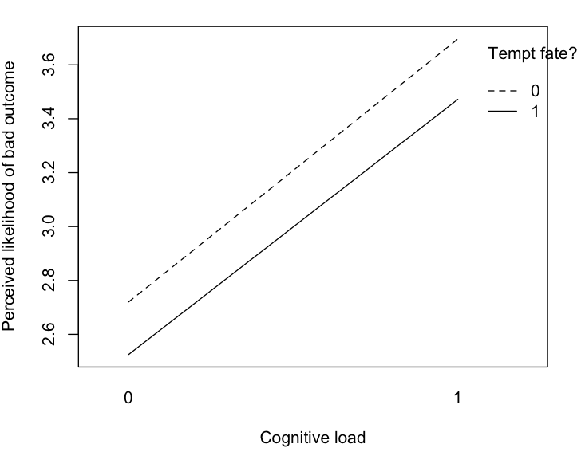

Since the likelihood variable was strongly right-skewed, we also performed the 2-way ANOVA with a $\sqrt{x}$ transformation of likelihood, whose distribution appeared to be much closer to Normal. This analysis yielded very similar results to the untransformed analysis, as expected with a large sample size.

Exploratory analyses

None.

**Discussion**

Summary of replication attempt

The two key predictions of the original study were 1) an interaction between tempting fate behavior and cognitive load, such that being under load increases perceived likelihood more after having tempted fate than after not having tempted fate, and 2) a main effect of tempting fate behavior, such that tempting fate increases perceived likelihood. Our data failed to replicated both of these findings.

Commentary

As discussed earlier, the online environment poses potential problems for replication, both due to the experiences and values of a different demographic population and due to the difficulty of adequately controlling cognitive load. Assessing the possible attenuating effect of these issues is difficult; to our knowledge, there has not been research attempting to validate the cognitive load paradigm in an online environment.

1. Rand, D.G., The promise of Mechanical Turk: How online labor markets can help theorists run behavioral experiments. J. Theor. Biol. (2011), doi:10.1016/j.jtbi.2011.03.004